**Lab1 – Backpropagation**

**314552036 周子翔**

1. **Introduction**

This report presents the implementation and evaluation of a simple neural network with two hidden layers trained using the backpropagation algorithm. The network is designed to classify data generated by synthetic datasets. The goal is to understand the role of activation function, weight, biases, and hyperparameters in training a neural network.

1. **Implementation Details**
   1. **Network Architecture**

The neural network consists of:

* Input Layer: Accepts 2-dimensional input data.
* Hidden Layers: Two hidden layers with configurable numbers of neurons.
* Output Layer: A single neuron for binary classification.
* Weights and Biases: Initialized using He initialization to improve convergence.
  1. **Activation Functions**
     1. **Sigmoid:**
        1. Sigmoid: $σ\left(x\right)=\frac{1}{1+e^{-x}}$
        2. Derivative: $σ^{'}= σ\left(x\right)*\left(1-σ(x\right))$
     2. **ReLU**
        1. ReLU: $f\left(x\right)=max(0, x)$
        2. Derivative: $f^{'}\left(x\right)= \left\{\begin{aligned}0 for x<0 \\ 1 for x≥0\end{aligned}\right.$
  2. **Backpropagation**

The backpropagation algorithm computes gradients of the loss function with respect to weights and biases:

$$dW_{i}=\frac{1}{m}A_{i-1}^{T}δ_{i}$$

$$db_{i}=\frac{1}{m}\sum_{k=1}^{m}{δ_{i,k}}$$

$$δ_{i}=(δ_{i+1}W_{i+1}^{T})∙σ^{'}(Z_{2})$$

1. **Experimental Results**
   1. **Screenshot and comparison figure**

**一張含有 螢幕擷取畫面, 圖表, 文字 的圖片

AI 產生的內容可能不正確。**

* 1. **Show the accuracy of your prediction**

Accuracy: 99.00%

* 1. **Learning curve (loss-epoch curve)**

**一張含有 文字, 圖表, 行, 繪圖 的圖片

AI 產生的內容可能不正確。**

* 1. **Anything you want to present**

**一張含有 螢幕擷取畫面, 天文學 的圖片

AI 產生的內容可能不正確。**

1. **Discussions**
   1. **Try different learning rates**
      1. Learning rate = 0.05

一張含有 文字, 螢幕擷取畫面, 圖表, 行 的圖片

AI 產生的內容可能不正確。

* + 1. Learning rate = 0.01

一張含有 文字, 圖表, 行, 繪圖 的圖片

AI 產生的內容可能不正確。

* + 1. Learning rate = 0.005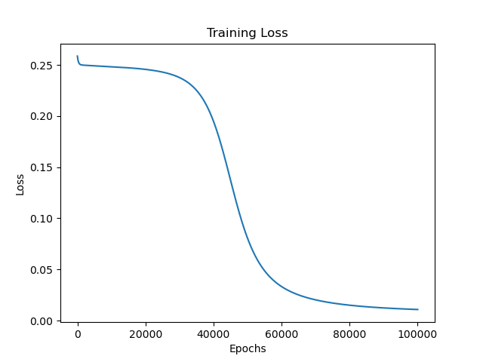
  1. **Try different numbers of hidden units**
     1. Hidden units = (4,3)

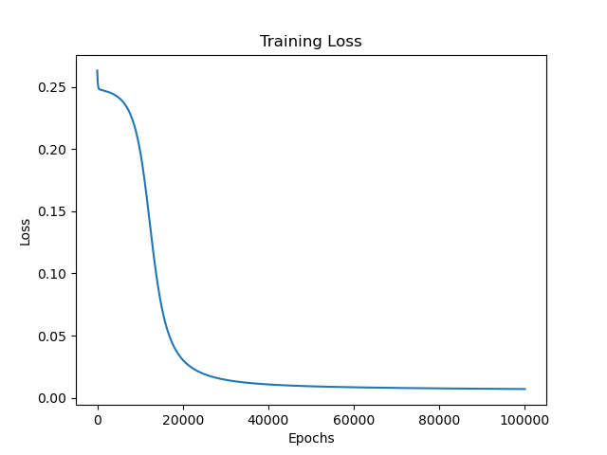

* + 1. Hidden units = (6,5)

一張含有 文字, 圖表, 行, 繪圖 的圖片

AI 產生的內容可能不正確。

* + 1. Hidden units = (8,7)

一張含有 文字, 螢幕擷取畫面, 圖表, 行 的圖片

AI 產生的內容可能不正確。

* 1. **Try without activation functions**

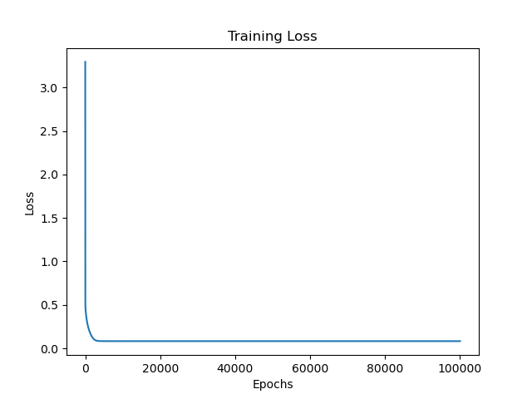

* 1. **Extra Implementation Discussions**

1. **Questions**
   1. **What are the purposes of activation functions?**

Activation functions introduce non-linearity into the network, enabling it to model complex relationships in the data. Without them, the network would behave like a linear model regardless of its depth.

* 1. **What if the learning rate is too large or too small?**

Too Large: The network may fail to converge or oscillate around the minimum.

Too Small: The network converges very slowly, requiring more epochs to reach an optimal solution.

* 1. **What are the purposes of weights and biases in a neural network?**

Weights: Determine the importance of each input feature and connection in the network.

Biases: Allow the network to shift the activation function, enabling it to fit the data better.